Create following form using tkinter widgets in python. Save all the user details in file.

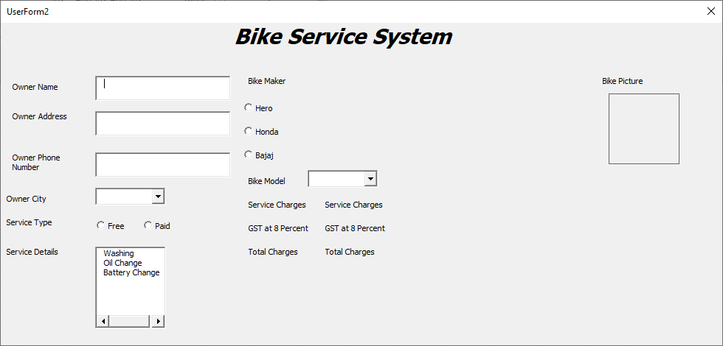

1. Write a function to fill up “Owner City” field with following cities: Anand, Nadiad, Changa, Vadtal.
2. Bike model should be filled up dynamically based on bike maker selected by the user. For example, if users selects Bajaj, the bike model combo box should be filled up with model names from bajaj.
3. Consider following charges for different services: Washing – Rs. 100, Oil Change – Rs. 250, Battery Change – Rs. 1200.
4. Calculate charges for the service and show in Service charges label. If the user has selected free service, service charges should be 0. Apply appropriate GST and calculate total charges payable by the user.

Create following form using Tkinter widget. Export all information in file.

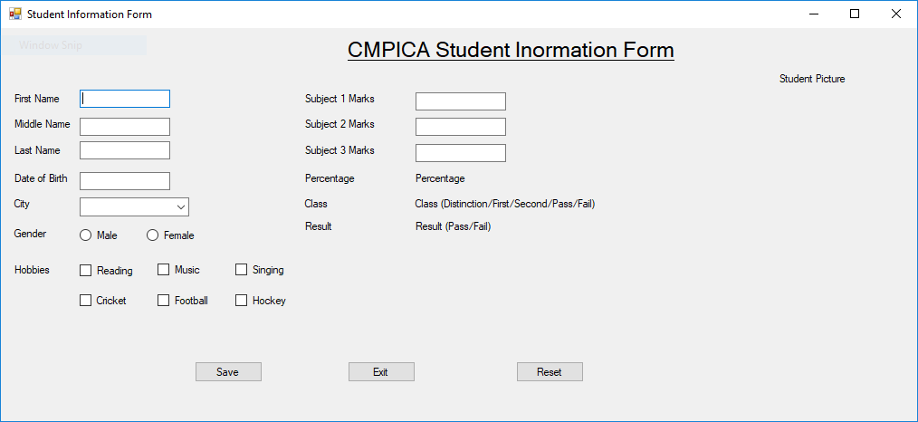

1. Write a function to insert city into City combobox.
2. Prepare a function to calculate and display following:
3. Based on Subject 1 marks, Subject 2 marks and Subject 3 marks calculate display percentage, class and result.
4. Clicking on reset should clear all the controls.
5. Clicking on exit should close the form.